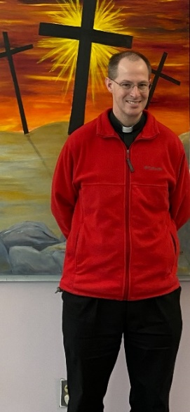
My Dear Brothers and Sisters,

You may remember a couple of years ago, Fr. Mike Schmitz began his “Bible in a Year Podcast.” It was the number one podcast for a while! Amazing! I certainly found it helpful to go through the whole Bible with good explanations. At times, it was hard, but always well worth it.

On January 1 of this year, he started a new podcast: “The Catechism in a Year Podcast.” Even though the publishing of this article is after January 1, with my travelling to Florida (to work at Cenacolo), I had to write this before the first episode dropped. I will be listening throughout the year, and I encourage you to, as well.

But this brings up the question: What is the Catechism? Over the centuries, the Church has had various summaries of her beliefs. We profess the Nicene Creed every Sunday as a reminder of what we believe. But a catechism gets into other parts of that belief, explaining more about what we believe. Some of you are old enough to remember having to memorize the Baltimore Catechism – those series of questions and answers about our beliefs.

Today, we have a universal Catechism, promulgated by Pope St. John Paul II. While I find it a useful tool, I’ve never actually sat down and read it straight through (I tried once in college, but stopped pretty quickly). Most often, I’ve used it as a resource for teaching, or a reference book for learning. This podcast is a great opportunity to see the whole Catechism.

It is important to note the layout of the Catechism. It is broken up into four major sections:
- The Profession of Faith (going through the Creed)
- The Celebration of the Christian Mystery (focusing on the Sacraments)
- Life in Christ (looking at our vocation of life in the Spirit and then the 10 Commandments)
- Christian Prayer

It is important to note the order of the Catechism. It doesn’t begin with the “Thou Shalts” and “Thou Shalt Nots.” No, it begins with relationship – the God in whom we believe. The Creed, of course, begins, “I believe in one God, the Father…” We start with our relationship to the God of the universe as Father. Then we move into how we are in relationship with Him – the Sacraments. He allows us to become His adopted children in Baptism!

It is only after these two steps that the Church focusses on morality (the 10 Commandments). We are reminded by this that every relationship has rules – written or unwritten – about how we are to relate to each other, how we are to treat each other. Christian Morality is about relationship. It is so important to note that we are not a religion about morality and ethics. No, we are a religion of relationship to God (in case you forgot: God wants to marry us), which then has moral/ethical implications: rights and responsibilities.

In the final section, the Catechism looks at Christian Prayer, and how we continue to build our relationship with God. This final part of the Catechism is written differently from the others, in that you could use this fourth section as a retreat guide.

I hope that you will take the opportunity with me to jump into learning more about our Catholic Faith through the “Catechism in a Year (with Fr. Mike Schmitz)”.

