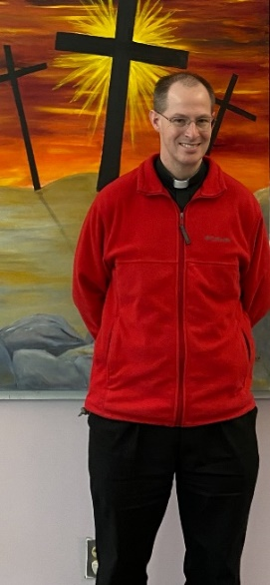
My Dear Brothers and Sisters,

Today’s Gospel shows us John the Baptist again. Here we see him pointing to Jesus and saying, “Behold, the Lamb of God, who takes away the sin of the world” (John 1:29). We use the term “Lamb of God” in the Mass: “Lamb of God, you take away the sins of the world, have mercy on us…” and “Behold the Lamb of God, behold him who takes away the sins of the world. Blessed are those called to the supper of the Lamb.” In the Gospels, we hear about the Lamb of God twice – both in the first chapter of John. St. Paul makes one reference to Christ as “our paschal lamb” (I Cor 5:7). St. Peter refers to Christ as the “spotless unblemished lamb” (I Peter 1:19). The book of Revelation has 29 references to lamb, and the majority of them are referring to Jesus.

But what does it mean that Jesus is the Lamb of God?

In our Christian culture (or more accurately: post-Christian), the idea of a bloody sacrifice is foreign to our understanding. Yet it was a part of most other religions since the dawn of man. Somehow, people knew there was a need to offer animals (and sometimes humans) to “the gods” in order to appease them. We see this in the ancient middle east, throughout the Greek and Roman pagan religions, in the pre-Christian European religions (think Druids in Ireland and the Germanic tribes), and even as recently as the 16th century in the Aztec religion – which required human sacrifice.

Even the Israelite religion was very much focused on animal sacrifice until the destruction the Jerusalem Temple in AD 70. In fact, at the Passover in the first century, historian Josephus writes about the hundreds of thousands of lambs that were slaughtered in the Temple for Passover. As Venerable Fulton Sheen put it, “The Jewish religion was a veritable hemorrhage of blood.”

Why?

The answer comes from the letter to the Hebrews, “without the shedding of blood, there is no forgiveness” (Hebrews 9:22). All of the ancient religions could somehow sense this truth. With the Passover – as God liberates Israel form the grasp of slavery – He uses the blood of a lamb to be the sign of protection against the angel of death. God then revealed to Moses on Sinai, that this was to the practice every year so that they should always remember God’s love and mercy, and never become complacent toward God. Throughout the Old Testament that God required a sacrifice, not to feed Him, or please Himself, but to help us to surrender in trust to the God who provides for us. We give Him back the first-fruit, the best of our work, of our lives, in order to thank Him for what He has done for us, and so open ourselves to His love and mercy.

When we say, then, that Jesus is the Lamb of God, we are saying that He is to be slaughtered for the forgiveness of sins. It reveals to us that the death of Jesus is salvation from the angel of death, and liberates us from the slavery to sin so that we can live as children of our God and Father. For John the Baptist to say that Jesus was the Lamb, was to say that He was a sacrifice – a bloody sacrifice – to God. How blessed we are that God shows us that we no longer have to slaughter animals – which could never really take away sins – nor offer human sacrifices to make up for our severed relationship with God. No, Jesus paid it all for us!

When we begin to think there’s no such thing as sin, when we say, “I’m ok and you’re ok,” let us remember how much it cost God to save us; may we remember the “Lamb of God.” It cost the Cross – because of His overwhelming, never-ending, reckless love for you and me. He doesn’t want us to feel bad or shameful for what it cost Him, but only to be ever thankful and to give Him our love.

May we be ever mindful of the incredible love of God, and respond to the Lamb with love in our hearts.

