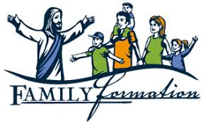
IN THE NEWS...
OUR DIOCESE WILL BE RESTORING THE ORDER IN WHICH THE SACRAMENTS OF INITIATION ARE CELEBRATED
—
BAPTISM, CONFIRMATION, FIRST HOLY COMMUNION.

Over the next few years, the standard age of Confirmation is going to be third grade throughout the Diocese of Manchester, and Confirmation will be celebrated before, not after, First Communion. This practice restores Confirmation to its original place. Through this process, the three Sacraments of Christian Initiation return to the logical order in which they were designed to be received: first Baptism, then Confirmation, then Eucharist. It also restores the practice of administering the Sacraments of Christian Initiation to young children as early as possible. Our parish has a plan for an implementation schedule, as well as a renewed vigor for implementing this change within the context of Lifelong Faith Formation. This will help us to provide an enriching experience of God's love through the sacramental life of the Church.
With that in mind, we as a parish welcome all of you with open arms to be a part of this exciting time in The Diocese of Manchester. Truly, a new Pentecost is upon us and Christ is calling us all back together so that we may be one in Him.
If you have any questions at all or would like to get your children registered for our Faith Life Program do not hesitate to call the office, or email me directly at faithlifeformation@comcast.net. The included registration form can be mailed to the office or brought to us in person.

In Christ,

Adam Castor
Director of Faith Life
St. Patrick Parish
Pelham, NH

