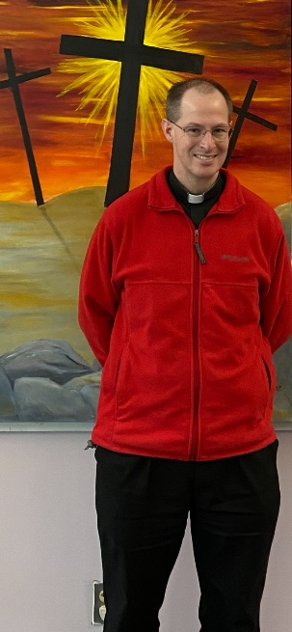
My Dear Brothers and Sisters,

In the Gospel today, we continue Jesus’ Sermon on the Plain (Luke’s parallel to Matthew’s Sermon on the Mount). Last week, we heard about the Beatitudes and Woes. We see in these how Jesus invites us to change our way of thinking. We are taught to look on life and the world in one way – the way of the culture – but Jesus teaches us to look on life and the world from the heavenly perspective.

This week’s Gospel is no different. The first words of Jesus in today’s Gospel are: “Love your enemies, do good to those who hate you” (Luke 6:27).

Whoa!

Again, Jesus throws a wrench into the way we see the world. From a superficial perspective, this sounds nice and beautiful. Practically speaking, though, it is incredibly difficult, even impossible without the help of God! An enemy is not someone I hate or dislike. An enemy is someone who is antagonistic to me – who is trying to hurt me. We hear in the first reading that King Saul is the enemy to David. Saul is actively pursuing David and trying to kill him. Yet David refuses to hurt Saul in any way. David loves his enemy.

The call to love our enemies is so difficult because to love someone means to will the good of the other. This means even when someone is backstabbing us at work, even when someone is trolling us online, even when someone is making our lives difficult at home, we are called (commanded, even) to do good to them, to will good for them, to speak good to and about them!

Ugh!

I think about the times when I have been libeled on Facebook, insulted to my face, or disrespected behind my back… how painful that has been. Yet, when I brought it to prayer, the Lord made it clear that I had to pray for them. As hard as that has been, it is an act of love, and, over time, my heart softens to the hurt done to me, I have been able to forgive, and – many times – the relationship has been healed. Even when it has not, God has brought me healing.

I’m remembering a woman in my first parish who always had a grimace on her face. I was afraid of her! I knew that I was not her favorite priest. But when she was on her way out of Mass, I always greeted her with a smile (even though it was difficult to do!). A few years later, she came up to me and said in a tone of annoyance, “Fr. Von, when you got here, I really didn’t like you. And then you would greet me with a smile, ‘Good morning!’ You were so annoying! I hated it! … But over time it began to work on me. And I came to like you.” She continued, still in her annoyed tone, “I just want you to know so that you keep doing that… it helps.”

Our love of our enemies really can change them. More importantly, it conforms us to the Heart of the Father! Even as God loves those who hate Him, so we are to love those who reject us and insult us and utter every kind of evil against us. May we learn from God to look at the world from His perspective, loving even those who do not love us.

