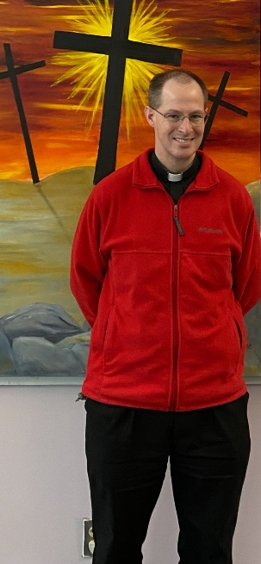
My Dear Brothers and Sisters,

I know you may not want to think about it, but Lent is only two and half weeks away. We celebrate Ash Wednesday on March 2 as the beginning of our preparation for Easter.

As always, the Church invites us to three practices during Lent: prayer, fasting and almsgiving. While the Church does not prescribe how we are to grow in prayer and almsgiving, it does give specific norms for the minimum fasting in Lent. The Church requires those who are 18-59 years old to fast on Ash Wednesday and Good Friday. This fast limits the person to a single full meal, with the option of two other smaller meals sufficient to maintain strength; however, together these two meals should not equal another full meal. The Church also requires all Catholics 14 years old and older to abstain from meat on Ash Wednesday and all Fridays in Lent (including Good Friday).

I don’t know about you, but every year when I get to this time, I start to wonder, “What am I going to do for Lent?” Sometimes, of course, it looks like giving something up, but it also means taking on other forms of prayer and almsgiving.

We have decided this year, as a way to help our parish grow in the Lenten observances, to have some Challenges. We are offering three challenges: Prayer, Fasting and Almsgiving. While there is a “form” for these challenges, there is also flexibility to help you tailor it to your own life.

The Prayer Challenge is to pray the Rosary – alone, with your family, or in some other way – each day during Lent. For the first 100 to sign up for the challenge, you will be given the book Mary’s Mantle Consecration: A Spiritual Retreat for Heaven’s Help. This book offers a one-page reflection for each of the 46 stars on the mantle of Our Lady of Guadalupe (corresponding to the 46 days between Ash Wednesday and Holy Saturday). If you sign up for this challenge, you have the option of receiving encouraging messages each day in Lent via e-mail, text or Facebook.

The Fasting Challenge is to take a step beyond the minimum fasting required by the Church, by choosing to fast on Wednesdays and Fridays. This can look like the simple fasting of the Church, to something stricter – like a bread and water fast. We know that as we work to control our appetite for food, we are able better to control other areas of our lives (e.g. curbing our sarcasm or judgment). If you sign up for this challenge, you will have the option of receiving inspirational messages about fasting by e-mail, text, or Facebook each Wednesday and Friday in Lent.

Our final challenge is the Almsgiving Challenge. This challenge is to give of our surplus to those who are in need. We are focusing on three concrete ways to help (although there are countless others): assisting the Pelham Food Pantry, filling the Poor Box, helping St. Gianna’s Place, and giving to GHB911. The Pelham Food Pantry is here on our St. Patrick campus and serves those in Pelham with food insecurity. The Poor Box supports those who come to the Parish Office in need of emergency assistance, and is located near the Chapel door in the Church. St. Gianna’s Place is a home in Hudson that cares for pregnant women in crisis. GHB911 is a nonprofit group dedicated to helping the homeless in nearby communities, and is currently collecting winter clothing: coats, hats, gloves, long johns, sweatpants and sweatshirts for men and women (men’s bigger sizes are in need). These items are collected every other Friday at the parish school (check the bulletin for details).

If you would like to sign up for one or more of these challenges, you can sign up either online (check our parish website or Facebook page) or by filling out a sign-up form in the pews and dropping it in the collection.

I truly hope these challenges help us to grow in prayer, fasting and almsgiving throughout Lent. More than that, though, I hope that it helps you grow closer to Jesus, and to prepare for the great feast of Easter!

